**Module 10 – Single Page Application framework – React**

**17.ReactJS-HOL**

**How to Consume REST APIs from React Applications**

In React applications, we often need to display dynamic data like user details, posts, or products. This data usually comes from a **backend server** through something called a **REST API**.

**What is a REST API?**

A REST API (Representational State Transfer API) is a way for your React app to **talk to another system** and get or send data using the internet (usually via HTTP requests).

**Why Use REST APIs in React?**

React is only a frontend library – it **doesn’t come with built-in data**. So if you want to:

* Show data from a database,
* Send form data to a server,
* Fetch random users or weather reports,

You’ll need to **call a REST API**.

**How to Consume a REST API in React?**

Here’s how it works step by step:

**1. Use a method to fetch the data**

* fetch() – built into JavaScript.
* axios – a popular external library (optional).

**2. Use React’s lifecycle or hooks**

* In class components → use componentDidMount()
* In function components → use useEffect()

**3. Store the data in a state**

Use useState() or this.setState() to store the API response.

**4. Render it in your JSX**

**Example (using function component and fetch()):**

import React, { useState, useEffect } from 'react';

function GetUser() {

const [user, setUser] = useState(null);

useEffect(() => {

fetch('https://api.randomuser.me/')

.then(response => response.json())

.then(data => setUser(data.results[0]));

}, []);

return (

<div>

{user ? (

<div>

<h1>{user.name.title} {user.name.first} {user.name.last}</h1>

<img src={user.picture.medium} alt="user" />

</div>

) : (

<p>Loading...</p>

)}

</div>

);

}

**What Happens Here:**

* useEffect runs once when the component loads.
* fetch() calls the API.
* The response is stored in user using setUser().
* JSX displays the name and photo once data is received.

**Summary**

* REST APIs help React apps **interact with backend services**.
* Use fetch or axios inside useEffect() or componentDidMount() to get data.
* Store the data in state and display it.

**Structure:**

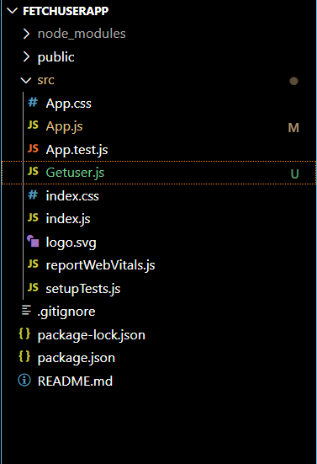

**Getuser.js:**

import React from 'react';

class Getuser extends React.Component {

  constructor(props) {

    super(props);

    this.state = {

      user: null

    };

  }

  async componentDidMount() {

    try {

      const response = await fetch('https://api.randomuser.me/');

      const data = await response.json();

      this.setState({ user: data.results[0] });

    } catch (error) {

      console.error('Error fetching user data:', error);

    }

  }

  render() {

    const { user } = this.state;

    return (

      <div style={{ textAlign: 'center', marginTop: '50px', fontFamily: 'Arial' }}>

        {user ? (

          <>

            <h2 style={{ color: 'black', fontSize: '30px' }}>

              {user.name.title} {user.name.first} {user.name.last}

            </h2>

            <img

              src={user.picture.large}

              alt="Random User"

              style={{ borderRadius: '10px', width: '100px', height: '100px' }}

            />

          </>

        ) : (

          <p>Loading user data...</p>

        )}

      </div>

    );

  }

}

export default Getuser;

**App.js:**

// src/App.js

import React from 'react';

import Getuser from './Getuser';

function App() {

  return (

    <div className="App">

      <Getuser />

    </div>

  );

}

export default App;

**Output:**

